**ICT171 Assignment 2**

**Student Name**: Ahmed Hameed Hussain  
**Student ID**: 35426534  
**DNS**: <https://vintagevogue.online/>

**IP Address:** 13.60.18.170

**NOTE:** Fonts in RED are commands to copy/paste to replicate.

**Introduction**

This tutorial is a step-by-step guide for deploying and setting up a cloud server on Amazon Web Services (AWS) host Vintage Vogue Clothing Store, the website of an online fashion clothing store. This project is targeted at developing an e-commerce high-performance, scalable, and secure site where people can shop and purchase clothing items. The website will begin with a static HTML frontend with future development plans to implement functionality in later stages such as dynamic product listing, shopping cart functionality, and secure user authentication.

**Project Planning**

Objective: To build a high-performance, scalable, and secure online fashion apparel shop on Amazon Web Services (AWS) Infrastructure as a Service (IaaS). The website will offer an easy-to-use and highly visual e-commerce solution that will allow customers to access and purchase fashion items easily while delivering high reliability and performance.

**Step 1: Setup and Configuration:**

I selected Amazon Web Services (AWS) as my server since it is reliable and well-documented.

**Step 2: Accessing the AWS Console:**

* Access the AWS Management Console.
* If you are not already registered, sign up first.
* Log in to your account with your credentials.

**Step 3: Launching an EC2 Instance:**

In the AWS Management Console, type "EC2" in the services search box and select it.

* Click on "Launch Instance" from the EC2 Dashboard.
* Under AMI (Amazon Machine Image), choose Amazon Linux.
* Select t3.micro instance type (Eligible for Free Tier).
* Click "Next: Add Storage" and stick with the default storage of 8GB.
* Configure a new security group to permit:

HTTP traffic (port 80)

SSH access (port 22)

* Create and download a secure access key pair.
* Review all the settings once again and click "Launch Instance".
* The instance will become available in 3-5 minutes after it's created.

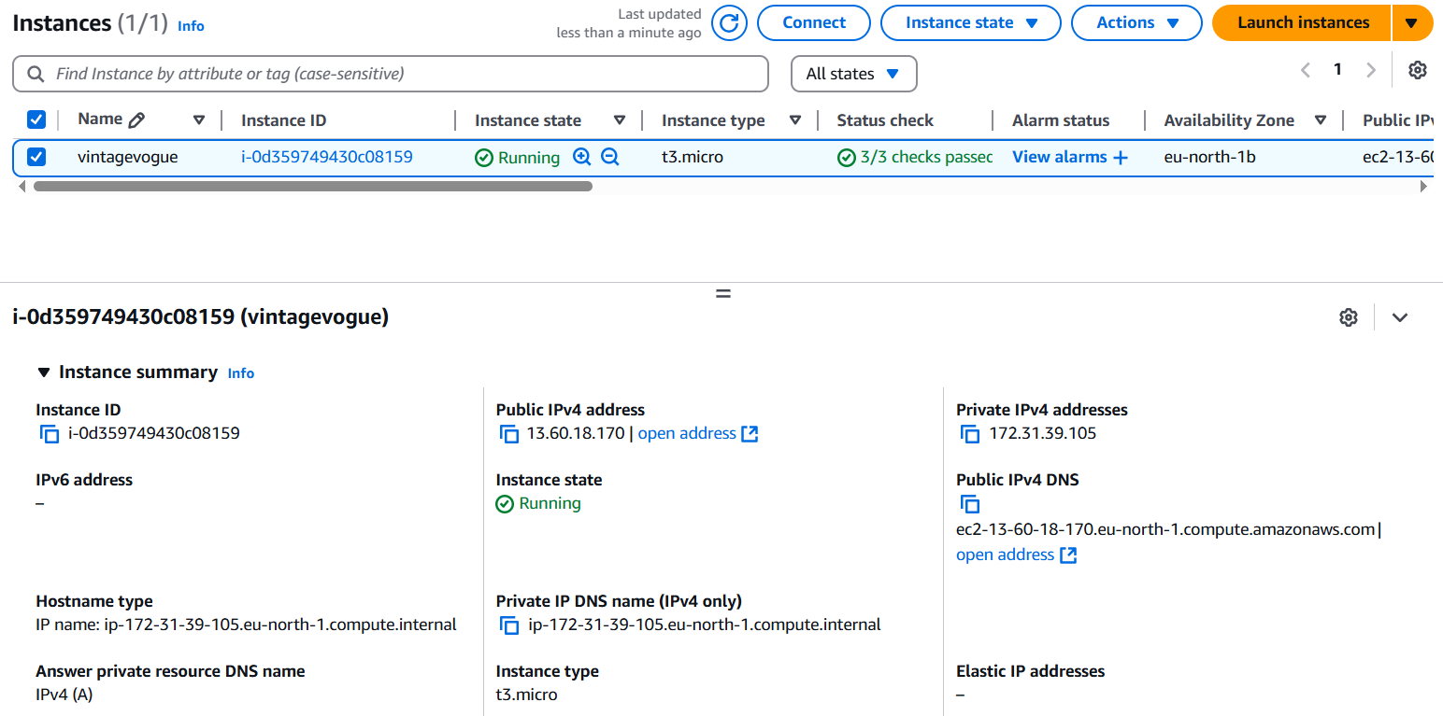

**Step 4: Connect to Your EC2 Instance:**

Get your instance information

* Note down your EC2 instance's public IP address 13.60.18.170
* Open a terminal on your local machine

Go to your key file directory

cd /home/User/Downloads

Give appropriate permissions to your key file

chmod 400 a.pem

Create SSH connection

ssh -i a.pem [ec2-user@13.60.18.170](mailto:ec2-user@13.60.18.170)

**Step 5: Set Up Your Web Server:**  
Update Package Manager  
sudo yum update -y  
  
Install Apache Web Server  
sudo yum install httpd -y  
sudo systemctl start httpd  
sudo systemctl enable httpd

**Step 6: Compress and Deploy Website Files:**

Compress files (From the correct source directory)

tar -czvf vintagevogue.tar.gz -C /home/User/Downloads

Upload to EC2 instance using SCP

scp -i ~/Downloads/a.pem vintagevogue.tar.gz ec2-user@13.60.18.170:~

SSH into your instance and move/extract files

sudo mv ~/vintagevogue.tar.gz /var/www/html/

cd /var/www/html

sudo tar -xvzf vintagevogue.tar.gz

Set permissions (resolved path case sensitivity)

sudo chown -R apache:apache /var/www/html

sudo chmod -R 755 /var/www/html

**Step 7: Access Your Website:**

* Open AWS EC2 Dashboard.
* Locate your running EC2 instance and select it.
* Copy the instance's public IP address.
* Paste the IP address in the address bar of your browser (e.g., Chrome) and press Enter to access your website.

**Step 8: Domain & DNS Setup:**

* Purchased Domain vintagevogue.online from GoDaddy.
* You will need to set up DNS settings to link your domain to your EC2 instance

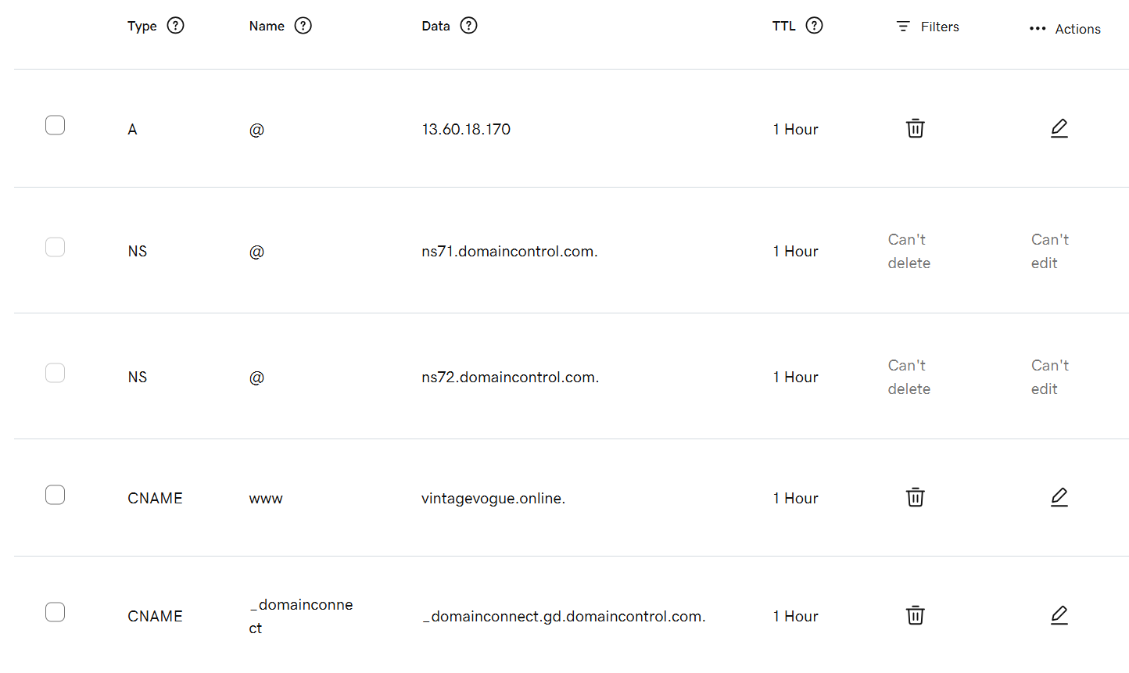

**Step 9: Connect Your Domain to the AWS Server:**

* Log into your GoDaddy account.
* Once you are inside your accounts, find the vintagevogue.online domain in your domains list.
* Add an A record that reflects your AWS instance public IP address.
* Wait for around 10-15 minutes for these changes to propagate.

**Step 10: Set up SSL with Let's Encrypt:**

* Get an SSL Certificate

Run the following commands in your AWS instance:

sudo yum install -y epel-release

sudo yum install -y certbot python3-certbot-apache

sudo certbot --apache -d vintagevogue.online

* Setting Automatic Renewal for the Certificate

Check if the automatic renewal service is active:

sudo systemctl status certbot.timer